PRODUCTS AND SERVICES
ESTIMATES, DESIGN, SUPPLY OF LABOR & INSTALLATION OF THE FOLLOWING

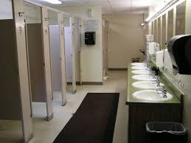
A. CIVIL WORKS & INTERIOR DESIGN

  - CEILING AND WALLING PARTITION
  - CR REHABILITATION & RENOVATION
  - PERIMETER FENCE &

RIP-RAPPING
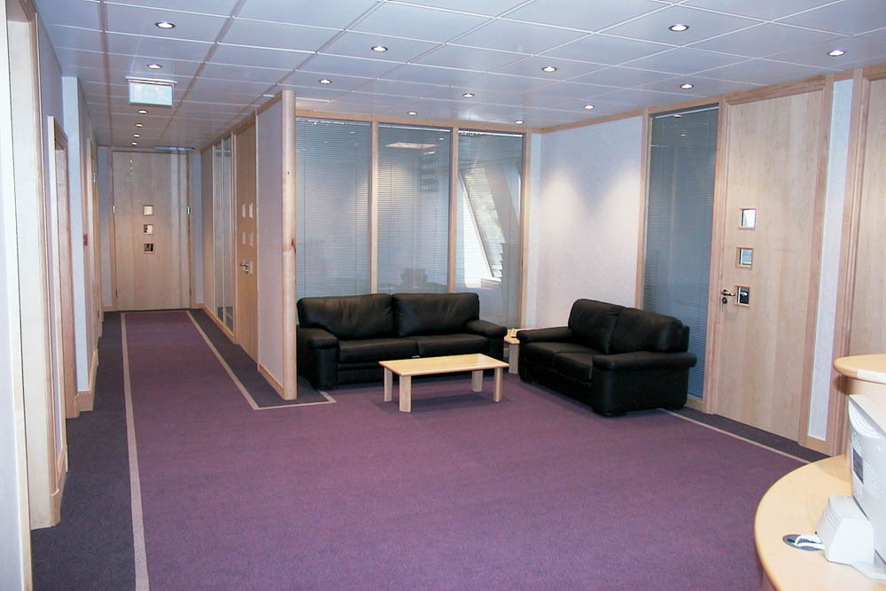
  - ROAD CONCRETING
  - DRAINAGE SYSTEM
  - TILLING WORKS
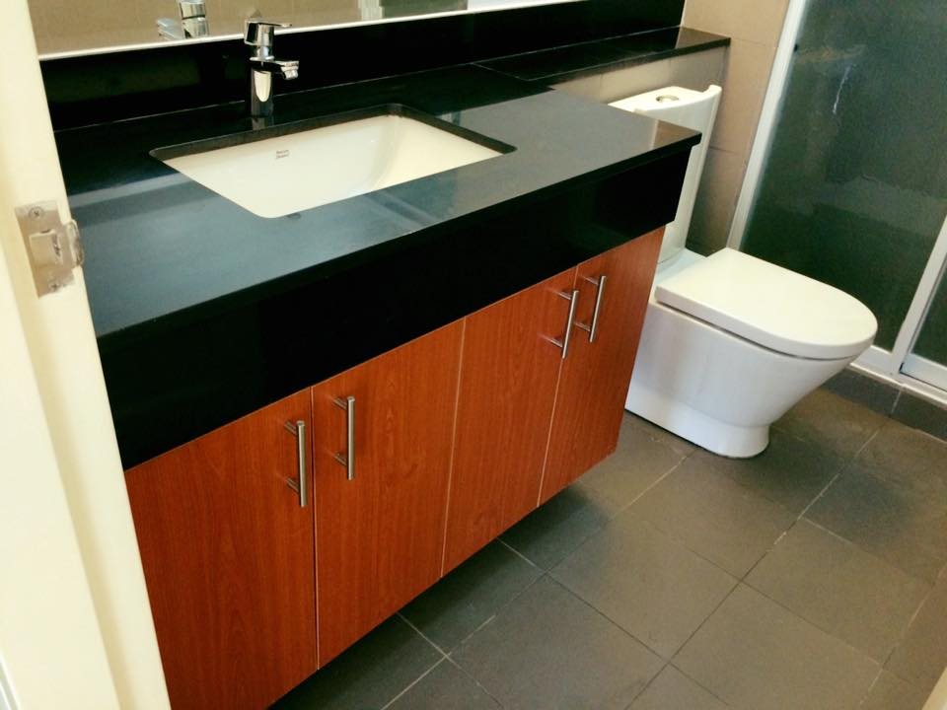
  - ROOFING INSTALLATION
  - WALL ALUMINUM CLADDING INSTALLATION

  - PLUMBING SYSTEM WORKS
  - PAINTING WORKS

BBJIS ENGINEERING SERVICES
Zone Okra, Paknaan,Mandaue City 6014 ,Philippines
Tel No. 6332-420-0342 -Cel.No. 0943-0565642 / 0916-6024218
Gmail Add : ecurb09.bbjis@gmail.com

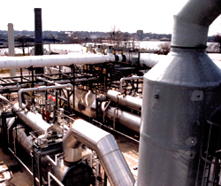
B. MECHANICAL WORKS Piping Works

  - G.I, B.I, STAINLESS AND ABS
(Acrylonitrile Butadiene Styrene ) Piping
System
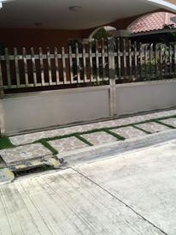
  - PPR Piping Stainless
  - Cooling Tower Installation Fabrication
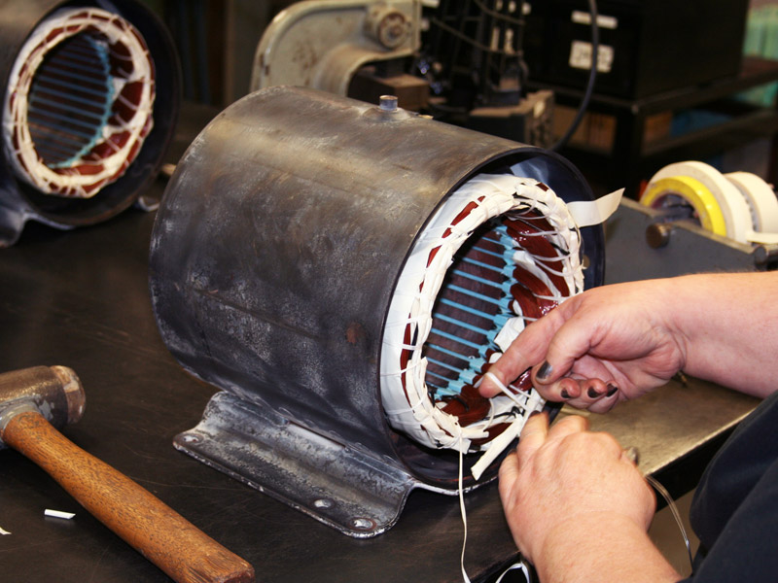
  - Airline and Steamline Piping Installation
  - Blower & Exhaust Installation
  - Erection & Rigging of Equipments
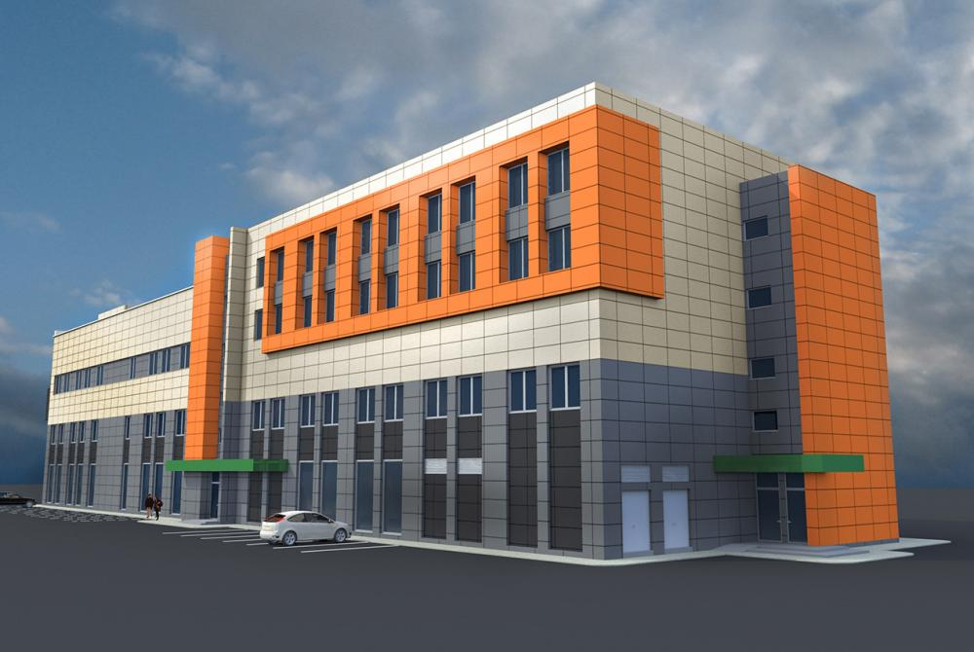
  - Installation & Fabrication of Stainless & motor rewinding
Ms Plate Tank
  - Installation of Stainless Railings,
Windows Grills, Gates, Kitchen Area wall cladding
  - Aluminum & Glass Materials Installation
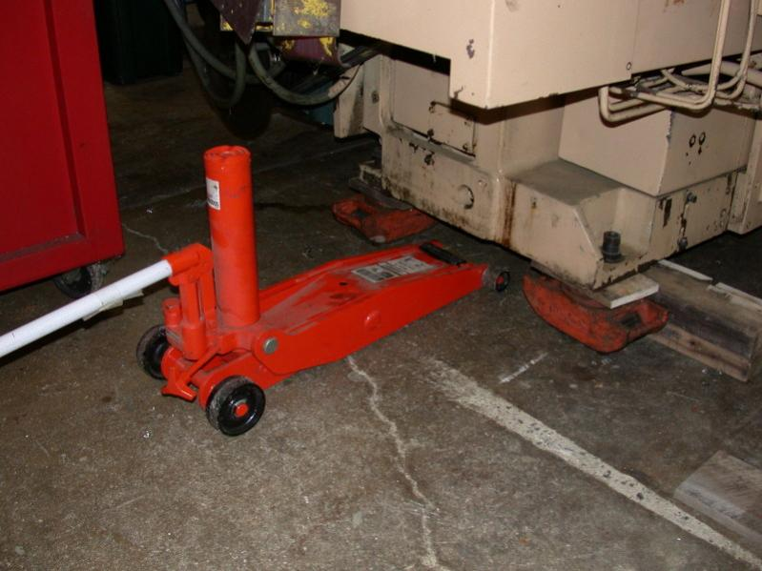
  - Fire Hydrant System
  - Motor Rewinding
Rigging Works

BBJIS ENGINEERING SERVICES
Zone Okra, Paknaan,Mandaue City 6014 ,Philippines
Tel No. 6332-420-0342 -Cel.No. 0943-0565642 / 0916-6024218
Gmail Add : ecurb09.bbjis@gmail.com

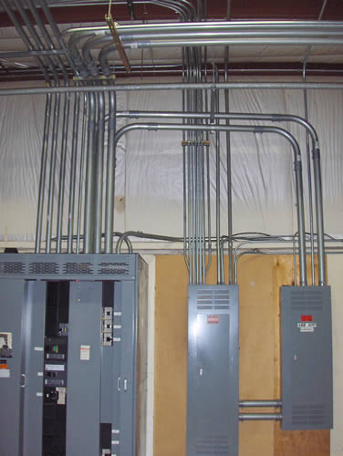

C. ELECTRICAL WORKS Panel Board Installation
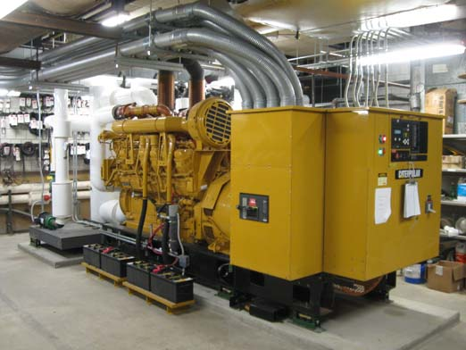
1.1 GENERAL LIGHTINGS
  - BUILDING WIRING SYSTEM
  - SUPPLY AND INSTALLATION
OF PANEL BOARDS
  - SUPPLY AND INSTALLATION OF
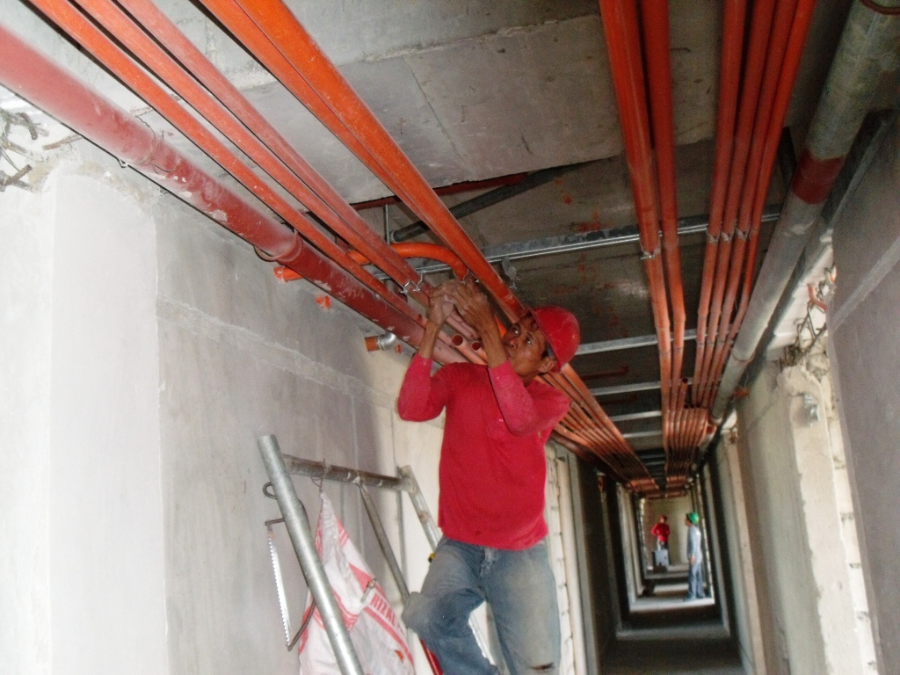
POWER CONTROL SYSTEM Generator Installation
  - AIRCONDITIONING SYSTEM
  - GENERATOR SET WIRING WORKS
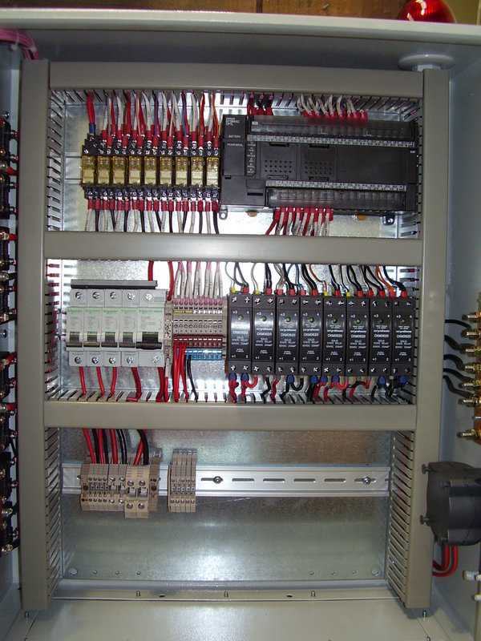
1.7 TESTING OF TRANSFORMER
1.8 EMERGENCY LIGHTS/ SAFETY & Building Wiring
EXIT LIGHTS System
1.9 CCTV CAMERA SYSTEM
1.10 ALARM SYSTEM ( FIRE, BURGLAR, ETC.)
Control Panelboard
BBJIS ENGINEERING SERVICES
Zone Okra, Paknaan,Mandaue City 6014 ,Philippines
Tel No. 6332-420-0342 -Cel.No. 0943-0565642 / 0916-6024218
Gmail Add : ecurb09.bbjis@gmail.com

D. PRODUCTS SUPPLIES
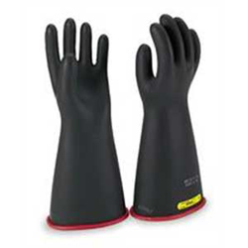
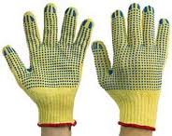
1.1 SAFETY GLOVES
2.2 HARD HAT
3.3 SAFETY SHOES
4.4 SAFETY GOGGLES
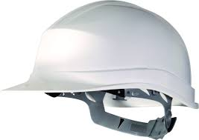
5.5 REFLECTORIZED VEST
6.6 SAFETY HARNESS
